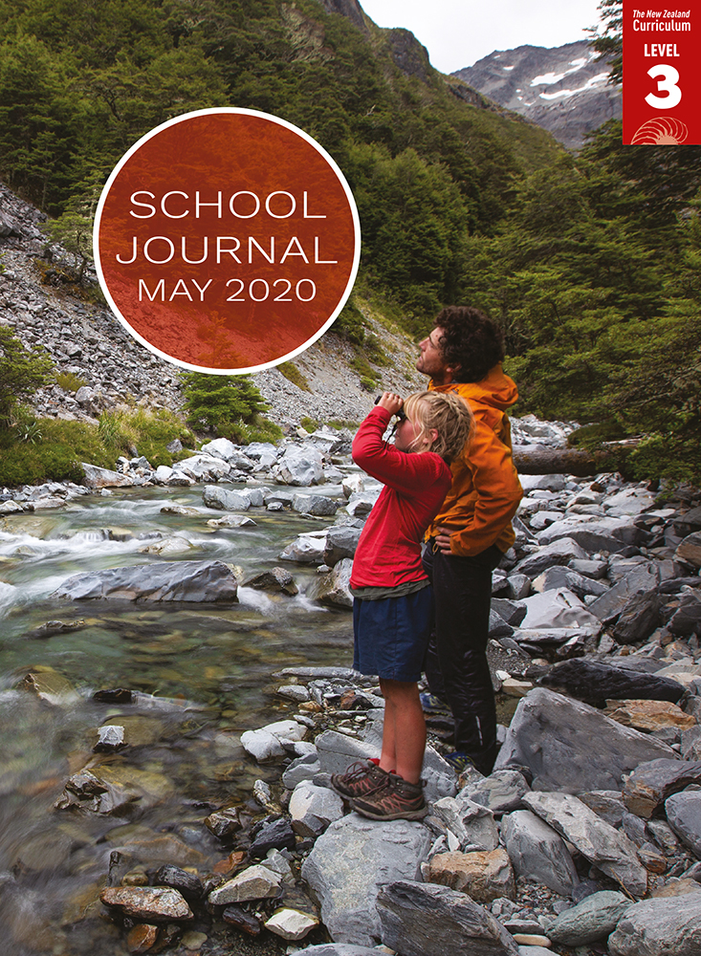

School Journal

Level 3, May 2020

**Year 5**

# Kia Māia

by André Ngāpō

[TheLearning Progression Frameworks](https://curriculumprogresstools.education.govt.nz/lpf-tool/) describe significant signposts in reading and writing as students develop and apply their literacy knowledge and skills with increasing expertise from school entry to the end of year 10.

## Overview

Jayson has just arrived in New Zealand to stay with his nan. He is staying at her marae preparing for an unveiling but is feeling out of his depth. With help from his younger cousin, Nikora, Jayson slowly feels his way, learning about tikanga Māori and how he, too, belongs.

A PDF of the text is available at [www.schooljournal.tki.org.nz](http://www.schooljournal.tki.org.nz)

## Themes

* Change
* Identity and belonging
* The importance of whānau/family

## Related texts

“**Koro’s Song**” SJ L3 Aug 2018 | “**Whānau**” SJ L3 May 2019 | “**Mossie**” SJ L2 Nov 2016 | “**Ask Eddie**” SJ L2 April 2013

## Strengthening reading behaviours (what to notice)

|  |  |
| --- | --- |
| Text structure and features | Requiring students to: |
| * Implied information or ideas (for example, the reason for Jayson’s mother’s absence and the fact that Jayson has been living in Australia makes him feel like an outsider) * Abstract ideas (such as the importance of whānau) * Aspects of tikanga Māori integrated into the story | * synthesise clues across the text to infer (for example, that perhaps Jayson’s mother has died) * use their prior knowledge of other stories or their personal experience to interpret the clues provided about the role of whānau in the story * apply their cultural knowledge along with descriptions in the text to understand and interpret the tikanga described. |

|  |  |
| --- | --- |
| Vocabulary | |
| Possibly unfamiliar words and phrases | macrocarpa, unveiling, strum, Perth, chords, Papua New Guinea, sultanas, accent, headstone, cemetery |
| Te reo Māori | mahi, wharekai, wharenui, hongi, hāngi, waiata, tikanga, karakia, kei te pai, whānau, marae, urupā, korowai, tapu, kai, hura kōhatu, tuakana, teina, manuhiri |
| Colloquial phrases | Sorry, cuz; You’ve gotta keep your eye on the ball; shoots me a look; my mind drifts |

|  |
| --- |
| Helpful prior knowledge (pre-reading and introducing the text) |
| * Tuakana–teina relationships are an important part of Māori relationships. * Tikanga Māori and marae protocols are closely observed in Māori culture. * Some English language learners may find this text difficult because of the marae setting and the inclusion of many te reo Māori words and colloquialisms. Take time when introducing the text to link to their prior knowledge and to build their background knowledge and vocabulary. Draw attention to the illustrations and how they support the text. Have the students predict word meanings and then check their predictions. Discuss how their own family members support each other and compare that with the way the characters in the story support each other. |

## Possible reading and writing purposes

* Explore how a young cousin helps his older cousin in an unfamiliar setting
* Identify how whānau support Jayson on his first visit to New Zealand
* Compare the perspectives of Jayson and his cousin at a special whānau gathering
* Explore the tikanga described in the story
* Identify, analyse, and record the literary features in the story.

See *Effective Literacy Practice in Years 5–8* for information about teaching comprehension strategies ([Teaching comprehension](http://literacyonline.tki.org.nz/Literacy-Online/Planning-for-my-students-needs/Effective-Literacy-Practice-Years-5-8/Teaching-comprehension)) and for suggestions on using this text with your students ([Approaches to teaching reading](http://literacyonline.tki.org.nz/Literacy-Online/Planning-for-my-students-needs/Effective-Literacy-Practice-Years-5-8/Approaches-to-teaching-reading)).

## Possible curriculum contexts

This text has links to level 3 of the New Zealand Curriculum in:[**ENGLISH**](http://nzcurriculum.tki.org.nz/The-New-Zealand-Curriculum/English)[**HEALTH AND PHYSICAL EDUCATION**](http://nzcurriculum.tki.org.nz/The-New-Zealand-Curriculum/Health-and-physical-education)

## Understanding progress

The following aspects of progress are taken from the [Learning Progression Frameworks](https://curriculumprogresstools.education.govt.nz/lpf-tool/) and relate to the specific learning tasks below. See the LPFs for more about how students develop expertise and make progress in these aspects:

* Reading for literary experience
* Making sense of text: reading critically
* Reading to organise ideas and information for learning
* Using writing to think and organise for learning.

## Strengthening understanding through reading and writing

The *School Journal* provides rich texts that can be returned to many times. The following suggestions are based on the premise that rereading the text is a fundamental part of developing students’ understanding and reading skills. **Select from and adapt** them, according to your students’ strengths, needs, and experiences.   
Note: Most of these activities lend themselves to students working in pairs or small groups.

* Have the students reread this story and related texts for information on marae protocol. They might arrange information graphically, showing the order of events and concepts that are connected by using arrows or symbols, or they might focus on the procedures for one aspect of tikanga, such as an unveiling, preparing food, or tuakana–teina relationships. They might also include a glossary.
* Explore how te reo Māori is supported in the story. Provide a template for students to record information, such as how the word is used in a sentence (showing how it is supported), the definition (in their own words), a drawing, and any related words or concepts.
* Track how Jayson changes during the story. Highlight any information in the text and transfer this to the **Tracking change** template provided. The students could tell or write about a time when they have experienced some of these changes.
* Alternatively, the students could track how their own thinking changed across the story, exploring why Jayson is unfamiliar with the situation, where he is from, and why his mum isn’t there. They could identify the text that has caused their thinking to change.
* Explore the narrative structure. Remind the students of similar, first-person narratives they have read. Have them think, pair, share and compare the features of stories, such as plot structure, order of events, time markers, use of dialogue, and characterisation. They might use this structure to tell a story about when they were in an unfamiliar setting and didn’t understand what was going on.
* Find examples of how the author has helped the reader to visualise, for example, through the use of adjectives in “Aunty Tina brings us egg sandwiches”, “putting the plate on a spare table at the back of the hall”, “porridge, nice and runny, with sultanas and tinned peaches, just how Dad makes it”. The students could talk about a personal connection they have, linking it to a part of the text, for example, “reading the part about … reminded me of the time when …”
* Have them talk about a cultural event that is important to them and their family.
* Ask the students to create a sociogram of the characters, recording all the main characters and using arrows to show relationships and connections. Single or double arrows might be used, adding text on the arrow that includes details such as “helps with food prep”, “cousin”, and “playing ball together”.  The students could do this using [MindMup](https://www.mindmup.com/).
* Have the students find character quotes or inferences and explain their meaning. The students pick a quote from a character and write it down for the group. In turns, the other students explain what they know or think about the character and what is meant by that quote. Examples could include: “‘They’ve earned a rest,’ she says. ‘It’s our turn to do the mahi now, but you can join them later.’”, “‘Pay attention to what Aunty says,’ Nan tells me. ‘It’s good practice for tomorrow.’”
* For more ideas and strategies to support English language learners, see [ESOL Online](https://esolonline.tki.org.nz/).

“Kia Māia” Tracking change

|  |  |  |  |
| --- | --- | --- | --- |
| **Jayson** | **At the start** | **During the story** | **At the end** |
| **Sense of belonging** |  |  |  |
| **Confidence** |  |  |  |
| **Identity** |  |  |  |
| **Ability or knowledge** |  |  |  |